Jira Lab Assignment 5

Harsh Rakeshkumar Bhatt

Project Management, Conestoga College

MGMT8750: Agile Project Management

Professor Shams Salim

June 20, 2023

Screenshot 1
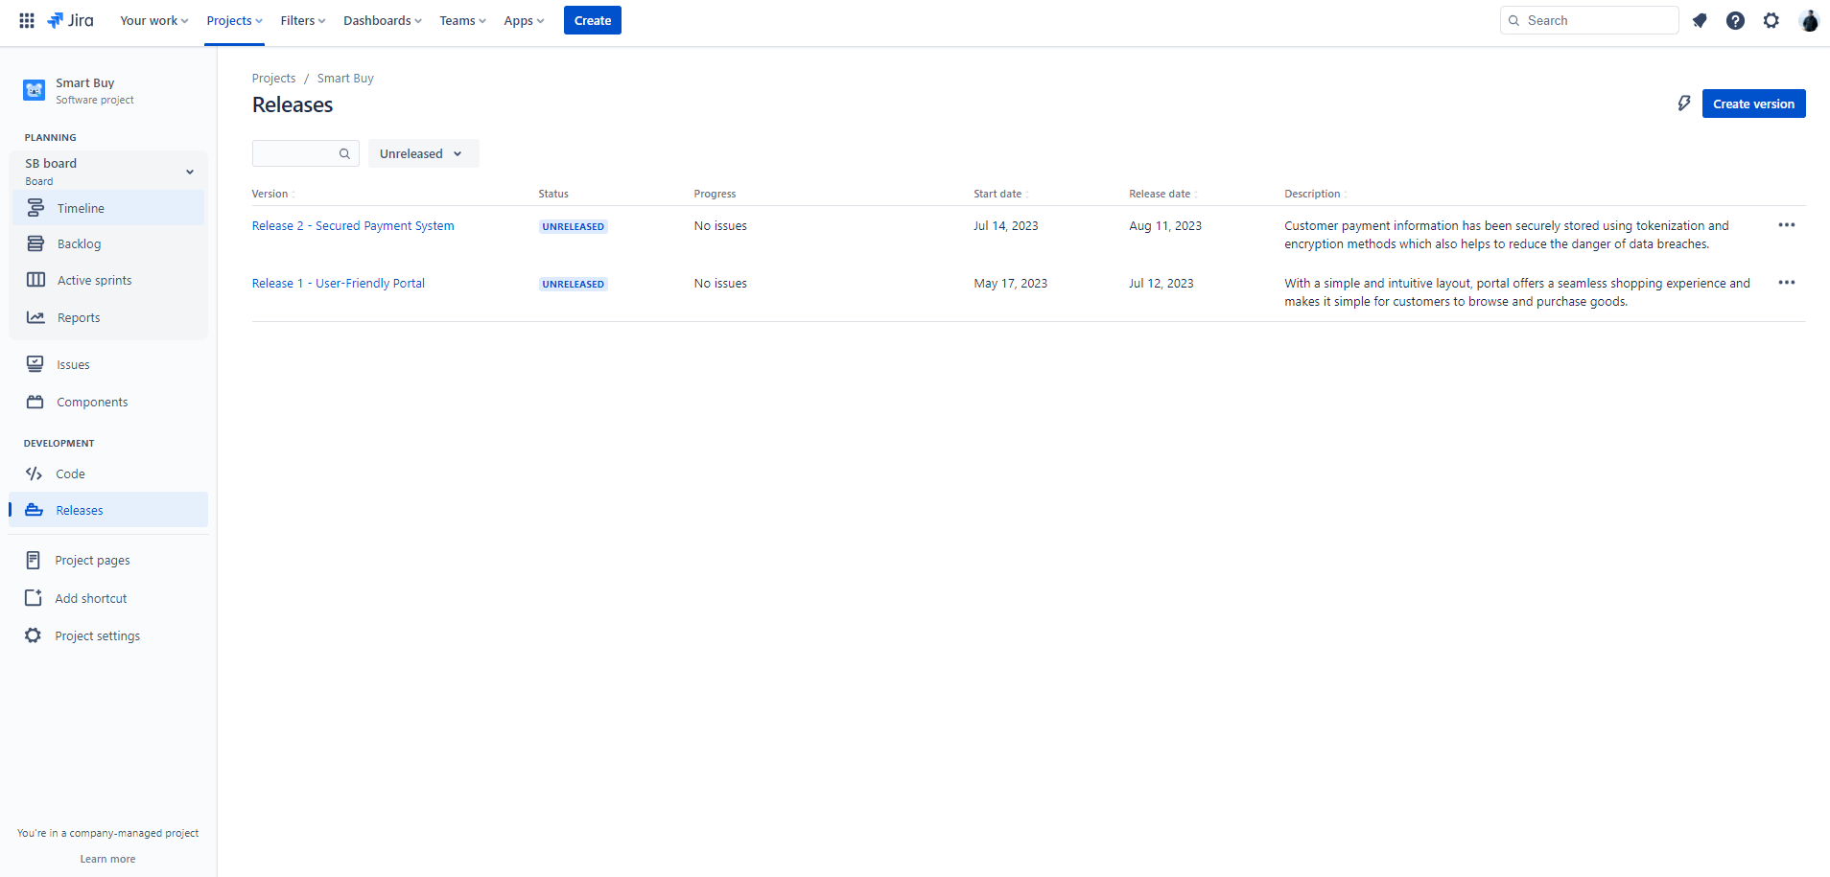

Screenshot 2
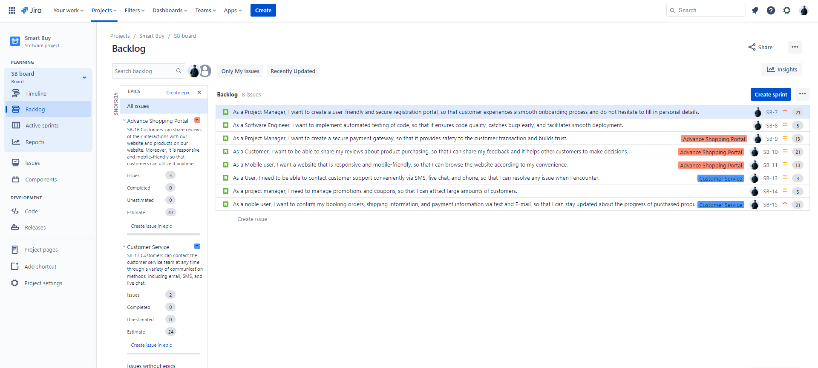

Screenshot 3
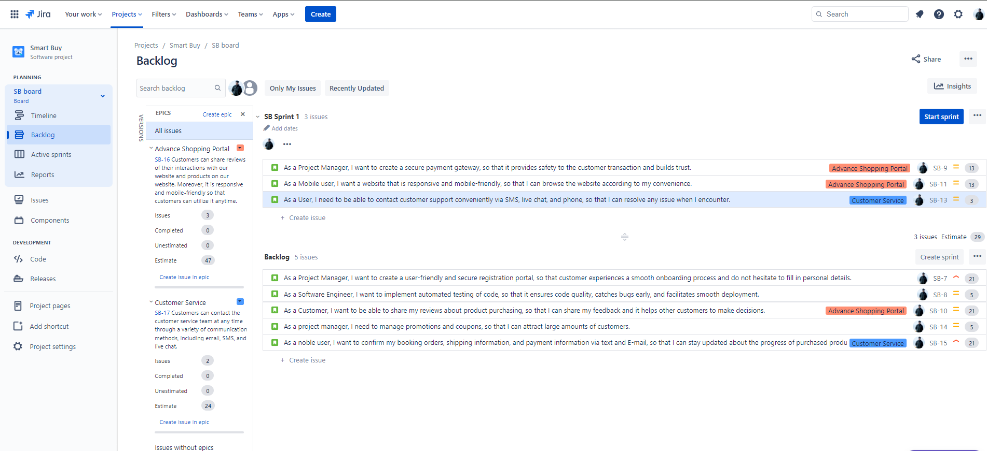

Screenshot 4
